Slide 01
Plateau Behavior in Multi-Objective Optimization
Uniform Discretisation Baseline vs. IPOPT Adaptive Bundle Method

Slide 02 | Plateau Definition: Detecting the Absence of New Best Values

Checkpoint Metric
$$ y_t = GN^*(\mathcal{B}_t) $$
The raw metric may fluctuate because GN* is solved numerically, the model is non-convex, and the Baseline evaluation set changes across checkpoints.

Best-so-Far Curve
$$ q_t = \min_{0 \le j \le t} y_j $$
- q_t records the lowest GN* value achieved up to checkpoint t.
- Because lower GN* is better, the best-so-far curve satisfies q_{t+1} <= q_t.
Precise definition The current detector defines a plateau as a sustained period in which the best-so-far GN* does not improve significantly. It does not require the raw metric to be perfectly horizontal.

Slide 03 | Plateau Detection Rule and Parameters
Let s be a candidate plateau onset. Each window contains w checkpoints, and c consecutive non-overlapping windows must satisfy the stability condition.
$$ \ell_b = s + bw, \qquad r_b = \ell_b + w - 1, \qquad b=0,\ldots,c-1 $$
$$ I_{s,b} = \frac{q_{\ell_b}-q_{r_b}}{\max(q_{\ell_b},\varepsilon_{\mathrm{num}})} $$
- Window condition: for every block b, the relative improvement must satisfy $$ I_{s,b} < \tau $$.
- Tail condition: the total best-so-far improvement from onset s to the end of the run must also be smaller than $$ \tau $$.
$$ I_s^{\mathrm{tail}} = \frac{q_s-q_T}{\max(q_s,\varepsilon_{\mathrm{num}})} < \tau $$
- The detector returns the first candidate s satisfying all conditions as the plateau onset.
- The plateau level uses the median of the raw GN* values after onset: $$ \operatorname{median}\{y_s,\ldots,y_T\} $$.
Parameter | Typical value | Definition | Effect of increasing
window (w) | 5 | Checkpoints per window | Requires a longer stable interval
consecutive_windows (c) | 2 | Number of consecutive stable windows | Makes detection more conservative
relative_improvement_tol (tau) | 0.05 | Significant-improvement threshold | Makes a plateau easier to declare

Default interpretation With w=5, c=2, and tau=5%, detection requires at least 10 checkpoints, and the best-so-far value cannot improve by 5% or more between onset and the end of the run.

Slide 04 | Experimental Setup and Parameters
Case | K | p | n | h | d | Resolution | Adaptive checkpoint | Detector (w,tau,c)
K4 | 4 | 3 | 20 | 2 | 20 | 4 | 700 | (4, 0.05, 2)
K5 | 5 | 5 | 25 | 2 | 27 | 3 | 1,000 | (5, 0.05, 2)
K6 | 6 | 6 | 30 | 2 | 32 | 3 | 1,500 | (5, 0.05, 2)
K7 | 7 | 7 | 35 | 2 | 37 | 3 | 2,800 | (5, 0.05, 2)
Common settings: seed=10, init_seed=11, steps_per_point_per_pass=5

Slide 05 | K=4 Results
K=4, p=3, n=20, h=2, d=20; budget=8,000; max_inner=20; lambda_max_starts=16.
- Baseline onset: 1,400 gradient evaluations; plateau level: $$ 2.341 \times 10^{-1} $$.
- Adaptive final value: $$ 2.045 \times 10^{-2} $$; no plateau was formally detected within the budget.
Main observation $$ \text{Baseline plateau} / \text{Adaptive final} \approx 11.5 $$. Adaptive continues to decrease under the same gradient-evaluation budget.
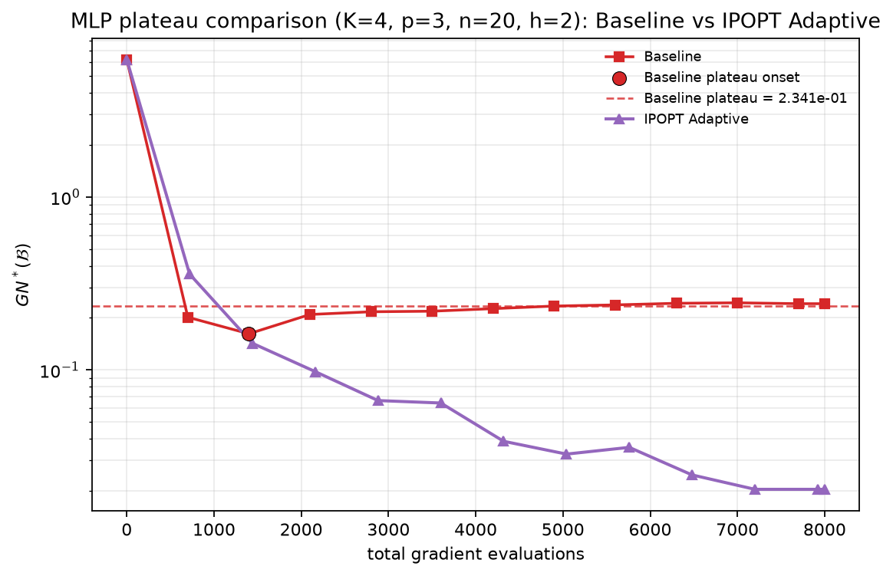
K=4 result: GN*(B) vs. total gradient evaluations

Slide 06 | K=5 Results
K=5, p=5, n=25, h=2, d=27; budget=10,000; max_inner=50; lambda_max_starts=20.
- Baseline onset: 1,750 gradient evaluations; plateau level: $$ 5.279 \times 10^{-1} $$.
- Adaptive final value: $$ 1.123 \times 10^{-1} $$; no plateau was formally detected within the budget.
Main observation $$ \text{Baseline plateau} / \text{Adaptive final} \approx 4.7 $$. Adaptive continues to decrease under the same gradient-evaluation budget.
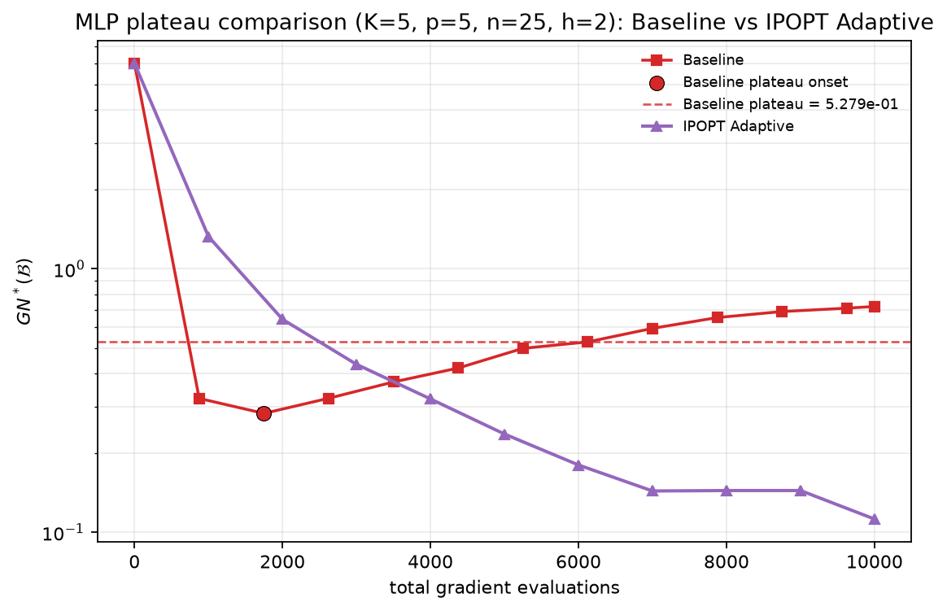
K=5 result: GN*(B) vs. total gradient evaluations

Slide 07 | K=6 Results
K=6, p=6, n=30, h=2, d=32; budget=18,000; max_inner=50; lambda_max_starts=20.
- Baseline onset: 3,360 gradient evaluations; plateau level: $$ 5.156 \times 10^{-1} $$.
- Adaptive final value: $$ 1.538 \times 10^{-1} $$; no plateau was formally detected within the budget.
Main observation $$ \text{Baseline plateau} / \text{Adaptive final} \approx 3.35 $$. Adaptive continues to decrease under the same gradient-evaluation budget.
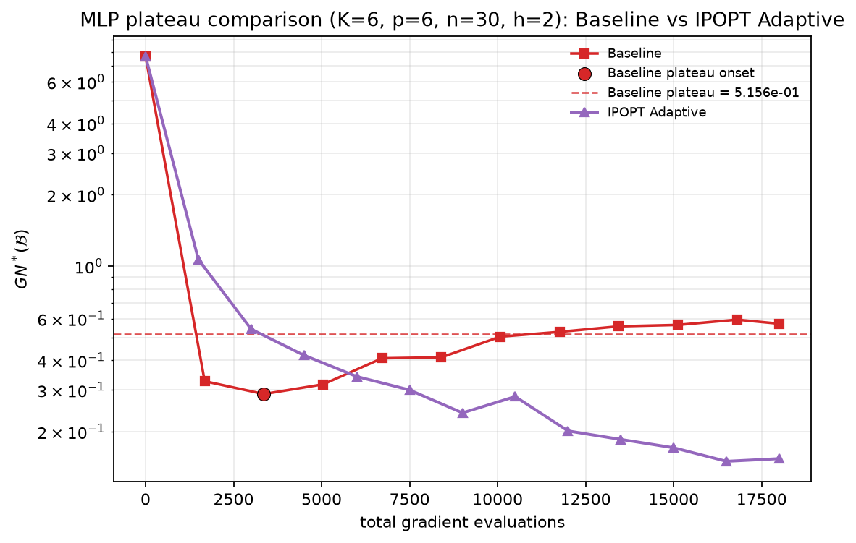
K=6 result: GN*(B) vs. total gradient evaluations

Slide 08 | K=7 Results
K=7, p=7, n=35, h=2, d=37; budget=32,000; max_inner=50; lambda_max_starts=20.
- Baseline onset: 5,880 gradient evaluations; plateau level: $$ 6.197 \times 10^{-1} $$.
- Adaptive final value: $$ \approx 1.6 \times 10^{-1} $$; no plateau was formally detected within the budget.
Main observation $$ \text{Baseline plateau} / \text{Adaptive final} \approx 3.9 $$. Adaptive continues to decrease under the same gradient-evaluation budget.
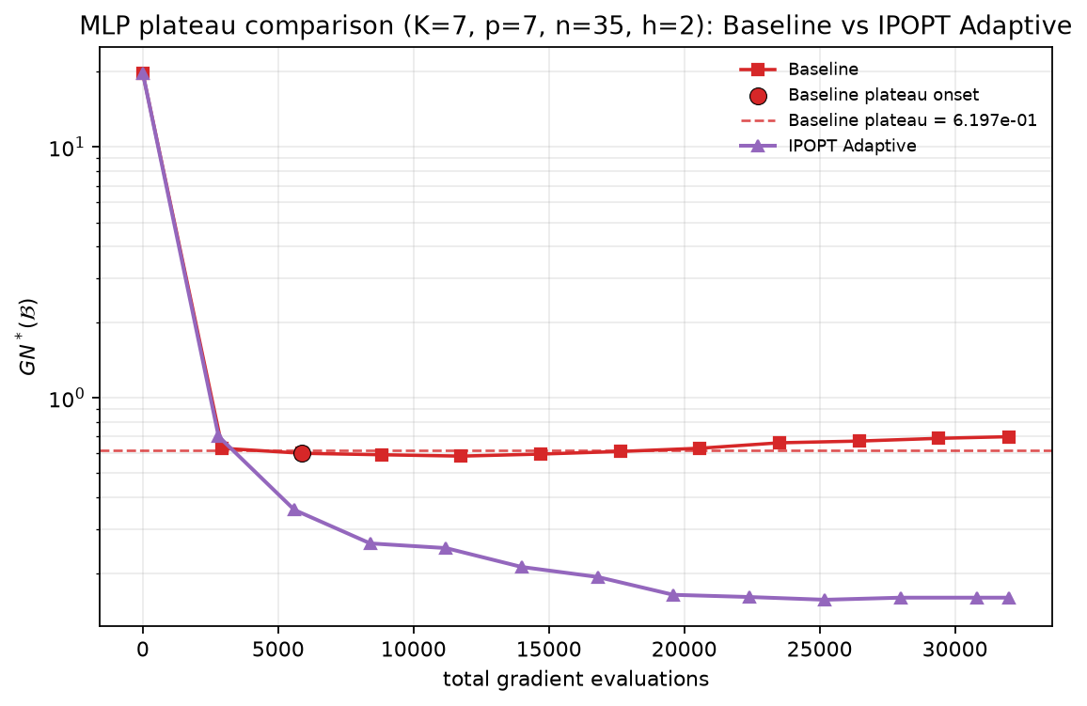
K=7 result: GN*(B) vs. total gradient evaluations

Slide 09 | Summary of K4-K7 Results
Case | Baseline plateau | Adaptive final | Adaptive plateau? | Ratio
K4 | 0.2341 | 0.02045 | No | ~11.5x
K5 | 0.5279 | 0.1123 | No | ~4.7x
K6 | 0.5156 | 0.1538 | No | ~3.35x
K7 | 0.6197 | ~0.16 | No | ~3.9x

Supported conclusion For K4-K7, the Baseline best-so-far value stops improving relatively early, while Adaptive reaches a substantially lower GN* under the same gradient-evaluation budget.
What cannot be claimed Adaptive was not detected as plateauing within these budgets, so the experiment is not yet a complete comparison of the final plateau levels of both methods.
- The ratio column compares the Baseline plateau level with the Adaptive final value; it is not a ratio of two plateau levels.
- The raw Baseline curves rise late in K4-K6; the detector interprets this behavior as an absence of new best values.

Slide 12 | Gradient Efficiency vs. CPU Efficiency
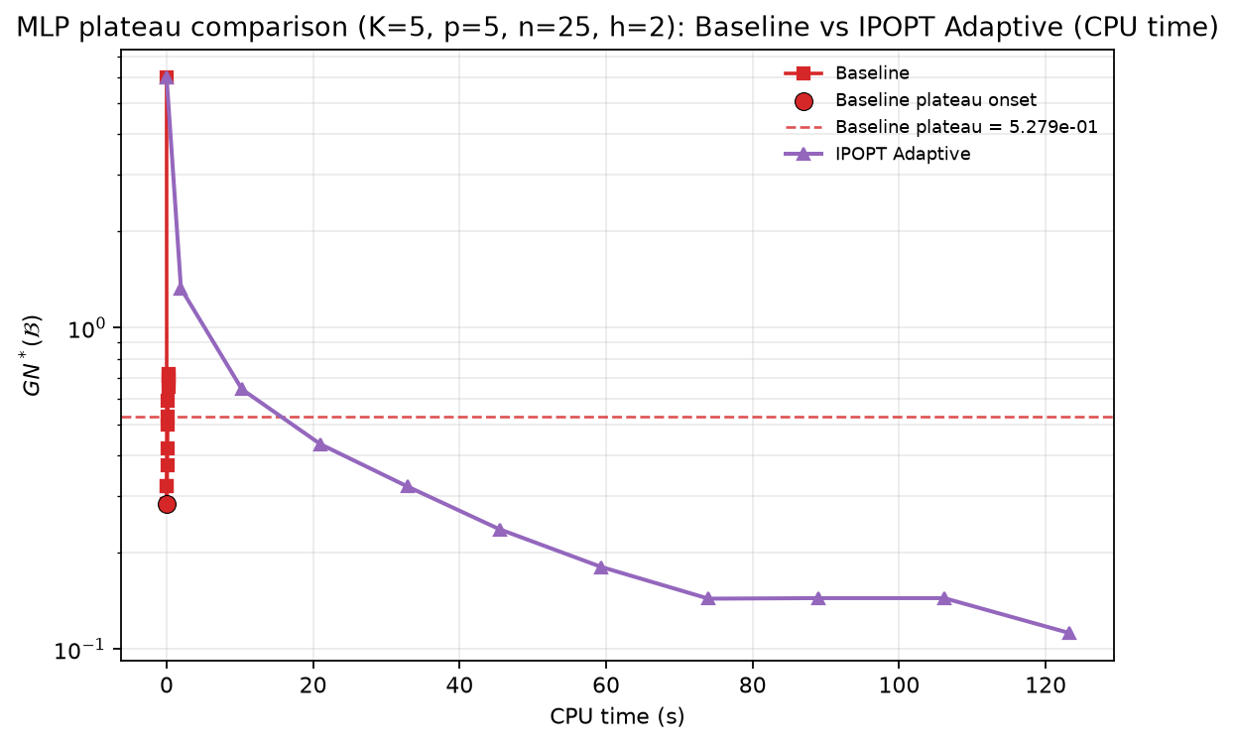
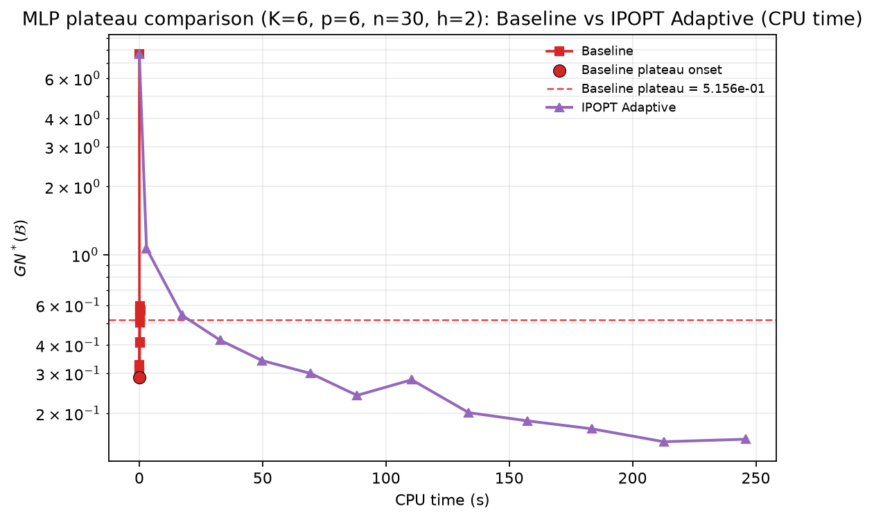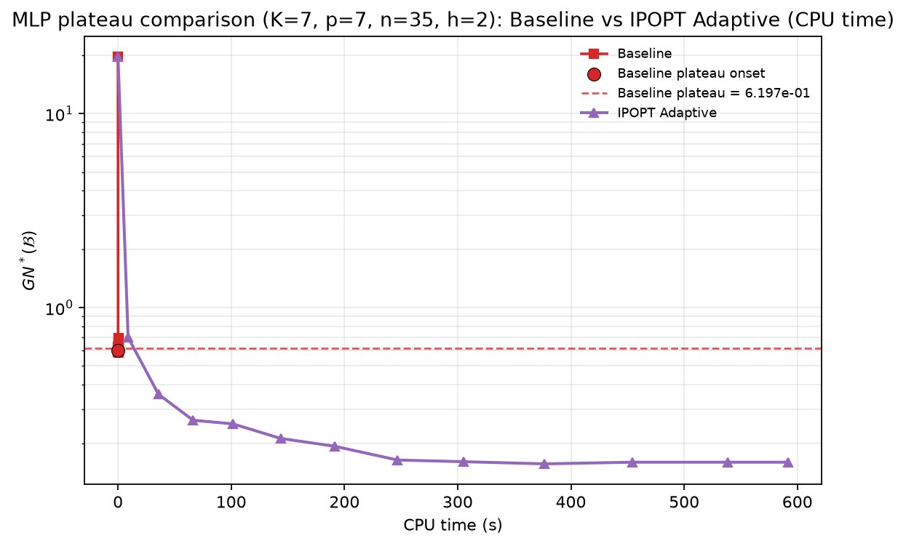
Representative CPU result (K=7): Adaptive incurs substantially higher computational cost

